1. For a homogenous circular cone of height H and base radius R, choose a body-fixed Cartesian coordinates system with its origin at the vertex of the cone and one of its axis lying along the cone. Calculate the inertial tensor of the cone with respect to the body-fixed Cartesian coordinate system.

The body-fixed coordinate system is chosen in the problem to make the off-diagonal terms of our inertia tensor zero. This will make our life easier because we only need to compute the diagonal terms $I_{11}, I_{22}$ and $I_{33}$. Our inertia tensor will look like the following:

$$I=\left[\begin{matrix}Σ_{σ}m_{σ}(r^{2}-x_{1}^{2}) & 0 & 0 \\ 0 & Σ_{σ}m_{σ}(r^{2}-x_{2}^{2}) & 0 \\ 0 & 0 & Σ_{σ}m_{σ}(r^{2}-x_{3}^{2})\end{matrix}\right]$$

Our first and second inertia terms are going to be the same because the problem doesn’t change if we rotate it around ${\hat{e}}_{0}^{3}$. This means we only need to solve the following terms:

$$I_{11}=I_{22}=Σ_{σ}m_{σ}\left(r^{2}-x_{1}^{2}\right)$$

$${I_{33}=Σ}_{σ}m_{σ}(r^{2}-x_{3}^{2})$$

First, I solved for the $I_{11}$ component because it seemed harder. To solve for the inertia, I started by solving for the rotational inertia of disk of thickness $dz$ and radius $r$ about the disk’s long edge (as if one were to spin a coin of its edge), then I used the parallel axis theorem to place the disk at position $z$ along the z-axis, and add all the disks up from $z=0$ to $z=h$. This method took several steps but it was well worth it in the end.

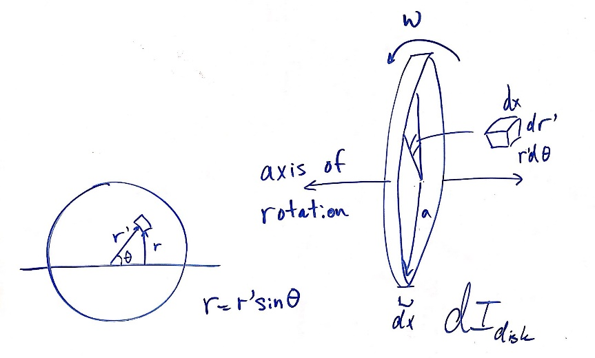

dz

dz

Here I defined the distance from the axis of rotation to $dm$ as the parameter $r$ and the radial distance from the center $r'$ of $dm$ as shown on the left of the figure. They are related by $r=r^{'}\sin{θ}$, where $θ$ is the angle with which $r$ makes with the axis of rotation. We will let $ρ=\frac{M}{V}=\frac{3M}{πR^{2}h}$. The inertia of our infinitesimal disk radius $a$ is:

$$dI=\int{r^{2}dm}=2\int_{r^{'}=0}^{a}{\int_{θ=0}^{π}{ρ{\left(r^{'}\sin{θ}\right)}^{2}r^{'}dθdr^{'}dx}}$$

$$dI=\frac{2ρa^{4}}{4}dx\int_{0}^{π}{\sin^{2}{θ}dθ}=\frac{ρπa^{4}}{4}dx$$

By parallel axis theorem, we can displace the inertia along the z-axis.

$$dI_{new}=dI+z^{2}dm$$

$$dI_{new}=\frac{ρπa^{4}}{4}dz+z^{2}ρπa^{2}dz$$

Where $dm=ρπa^{2}dx$ because that is the mass of our infinitesimal disk radius $a$.

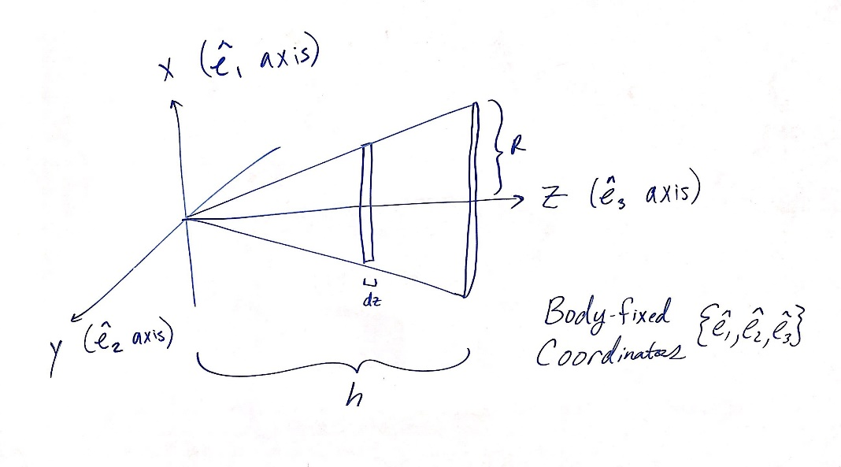

Now we add up all the disks from $z=0$ to $z=h$ in a cone formation. The parameterization $a=\frac{R}{h}z$ applies because the cone radius goes to zero at $z=0$ and $R$ at $z=h$.

$$I_{11}=\int_{z=0}^{h}{\left(\frac{ρπa^{4}}{4}dz+ρπz^{2}a^{2}dz\right)}$$

$$I_{11}=ρπ\int_{z=0}^{h}{\left(\frac{R^{4}}{4h^{4}}z^{4}dz+\frac{R^{2}}{h^{2}}z^{4}dz\right)} \\ I_{11}=ρπ\left(\frac{R^{4}}{4h^{4}}+\frac{R^{2}}{h^{2}}\right){\left[\left(\frac{z^{5}}{5}\right)\right]}_{0}^{h} \\ I_{11}=\left(\frac{3M}{πR^{2}h}\right)π\left(\frac{R^{4}h}{20}+\frac{R^{2}h^{3}}{5}\right) \\ I_{11}=3M\left(\frac{R^{2}}{20}+\frac{h^{2}}{5}\right)$$

All that’s left is $I_{33}$, which is much easier. We just use cylindrical coordinates to add up the rotational inertias about ${\hat{e}}_{0}^{3}$ which I will say lies along the z-axis.

$$I_{33}=\int{r^{2}dm}=\int_{z=0}^{z}{\int_{r=0}^{\frac{R}{h}z}{\int_{θ=0}^{2π}{ρr^{3}dθdr dz}}} \\ I_{33}=ρ2π\int_{0}^{h}{\frac{{\left(\frac{R}{h}z\right)}^{4}}{4}}dz=\frac{ρ2πR^{4}}{4h^{4}}\left(\frac{h^{5}}{5}\right)=\frac{ρπR^{4}h}{10} \\ I_{33}=\left(\frac{3M}{πR^{2}h}\right)\left(\frac{πR^{4}h}{10}\right)=\frac{3MR^{2}}{10}$$

Our inertia tensor is then:

$$I=3M\left(\begin{matrix}\frac{R^{2}}{20}+\frac{h^{2}}{5} & 0 & 0 \\ 0 & \frac{R^{2}}{20}+\frac{h^{2}}{5} & 0 \\ 0 & 0 & \frac{R^{2}}{10}\end{matrix}\right)$$

1. Calculate the intertial tensor of a homogenous cube of density $ρ$, mass M, and side length $b$ with respect to two different body-fixed Cartesian coordinate systems.
   1. In the body-fixed coordinate system $({\hat{e}}_{1},{\hat{e}}_{2},{\hat{e}}_{3})$, the origin $Q$ is at the corner and the three axes lie along the three adjacent edges.
   2. In the body-fixed coordinate system $({\hat{e}}_{1}',{\hat{e}}_{2}',{\hat{e}}_{3}')$, the origin $O$ is at the center of mass of the cube and its three axes are parallel to those axes.

The setup for this problem is much like problem 1, except we now have to perform many integrals because the axis in part a is not the principle axis. To make my life easier, I recruited the abilities of Mathematica to perform these exhaustive calculations.

The code was quite simple, I just computed the inertia tensor values by indexing them and making use of Mathematica’s $KroneckerDelta[i,j]$ function, which is 1 for $i=j$, and zero for $i≠j$.

The elements of the matrix are computed with respect to their index. Every element can be generated for a continuous body by:

$$I_{i,j}=\int{dx_{1}dx_{2}dx_{3}ρ\left(δ_{i,j}\left(x_{1}^{2}+x_{2}^{2}+x_{3}^{2}\right)-x_{i}x_{j}\right)}$$

For part (a), the bounds of the integral are from the ${\hat{e}}_{0}^{1}$ axis to $a$, the ${\hat{e}}_{0}^{2}$ axis to $b$, and from the ${\hat{e}}_{0}^{1}$ axis to $c$ because the axis of rotation is placed along the edge ${\hat{e}}_{0}^{1}$. I also gave the cube arbitrary dimensions $a, b, c$ for generalization. The generalized inertia tensor is:

$$I=ρ\left(\begin{matrix}\frac{1}{3}abc\left(b^{2}+c^{2}\right)p & -\frac{1}{4}a^{2}b^{2}cp & -\frac{1}{4}a^{2}bc^{2}p \\ -\frac{1}{4}a^{2}b^{2}cp & \frac{1}{3}abc\left(a^{2}+c^{2}\right)p & -\frac{1}{4}ab^{2}c^{2}p \\ -\frac{1}{4}a^{2}bc^{2}p & -\frac{1}{4}ab^{2}c^{2}p & \frac{1}{3}ab\left(a^{2}+b^{2}\right)cp\end{matrix}\right)$$

The intertia tensor for $a=b=c$ is

$$I=ρa^{5}\left(\begin{matrix}\frac{2}{3} & -\frac{1}{4} & -\frac{1}{4} \\ -\frac{1}{4} & \frac{2}{3} & -\frac{1}{4} \\ -\frac{1}{4} & -\frac{1}{4} & \frac{2}{3}\end{matrix}\right)=$$

$$I=Ma^{2}\left(\begin{matrix}\frac{2}{3} & -\frac{1}{4} & -\frac{1}{4} \\ -\frac{1}{4} & \frac{2}{3} & -\frac{1}{4} \\ -\frac{1}{4} & -\frac{1}{4} & \frac{2}{3}\end{matrix}\right)$$

Where $ρ=\frac{M}{a^{3}}$

In part (b), the bounds of the integral were changed to center the box at the origin, with the axis of rotation along ${\hat{e}}_{0}^{1}$. This ends up being the principle axis of rotation because the inertia tensor has no off-diagonal components.

$$I=ρ\left(\begin{matrix}\frac{1}{12}abc\left(b^{2}+c^{2}\right)p & 0 & 0 \\ 0 & \frac{1}{12}abc\left(a^{2}+c^{2}\right)p & 0 \\ 0 & 0 & \frac{1}{12}ab\left(a^{2}+b^{2}\right)cp\end{matrix}\right)$$

The inertia tensor for $a=b=c$ is

$$I=ρa^{5}\left(\begin{matrix}\frac{1}{6} & 0 & 0 \\ 0 & \frac{1}{6} & 0 \\ 0 & 0 & \frac{1}{6}\end{matrix}\right)=Ma^{2}\left(\begin{matrix}\frac{1}{6} & 0 & 0 \\ 0 & \frac{1}{6} & 0 \\ 0 & 0 & \frac{1}{6}\end{matrix}\right)$$

(See last page of Mathematica code)

ClearAll[r, x1, x2, x3, i, j, p, a, b, c, InertiaCorner,

InertiaCenter]

(* Define a, b, c, rho here...*)

a = a;

b = b;

c = c;

p = p;

r = {x1, x2, x3};

integrand[r_] =

p*(KroneckerDelta[i, j]*(r[[1]]^2 + r[[2]]^2 + r[[3]]^2) -

r[[i]]*r[[j]]);

InertiaCorner =

Table[Integrate[

integrand[r], {r[[1]], 0, a}, {r[[2]], 0, b}, {r[[3]], 0,

c}], {i, 3}, {j, 3}];

MatrixForm[InertiaCorner]

InertiaCenter =

Table[Integrate[

integrand[r], {r[[1]], -a/2, a/2}, {r[[2]], -b/2,

b/2}, {r[[3]], -c/2, c/2}], {i, 3}, {j, 3}];

MatrixForm[InertiaCenter]